1/13/10 Pastor Hani Sayegh (Akko Israel) Evangelical Baptist Church of Akko
P.O. Box 2626 Akko, Israel 24203, E-Mail: ebc_akko@hotmail.com

So in everything, do to others what you would have them do to you…
Matthew 7:12
When considering the verse above, it brings to mind the question, how many people during the Christmas season are in need of a spiritual uplift? Well with our church in Akko each year this very thought moves from word into deed.
Christmas time is full of ministry. We start in mid month by doing what we call “Christmas visiting”. This involves visiting believing and unbelieving families in Akko and the surrounding Arab villages. In each house we sing carols and pray for the family and their home. It is a time of joy and peace, a practice that truly needs to be experienced.
For the believing families this is time of encouragement. It is a way of acknowledging our love and the gracious hand that the Lord has placed on us.
The goal for the unbelievers was to open doors so we could speak freely. At Christmas season, this enabled us to talk about the Lord, the reason for His coming and a chance to give the salvation message. Several people accepted the Lord into their hearts. One person in particular is a teacher in Akko who is also an author. He called and said that he wanted a meeting in his house, “not just a 15 minute meeting but a full meeting with a Bible study”.
On the 25th of December we have a very interesting annual event. This is when we bring together the different leaders in the community for a time of unity and peace. These visitors included the Mayor and assistant Mayor of Akko, heads of the police and many of the Imams of the Mosques in Akko. Pastor Hani does not let a moment slip by without the chance to give the Gospel message. With all the parties there, he thanked them, blessed them and then proceeded to give the reason that we believe that Jesus was the Messiah. Hallelujah. The word will not come back void!
December 26th. We had a wonderful Christmas dinner. An evening with music, food, a Bible trivia contest and yes, a few Santa’s giving out candy. You can follow the link below to see a YouTube video of the celebration sung in Arabic. http://www.youtube.com/watch?v=DBA5R_wDjXI
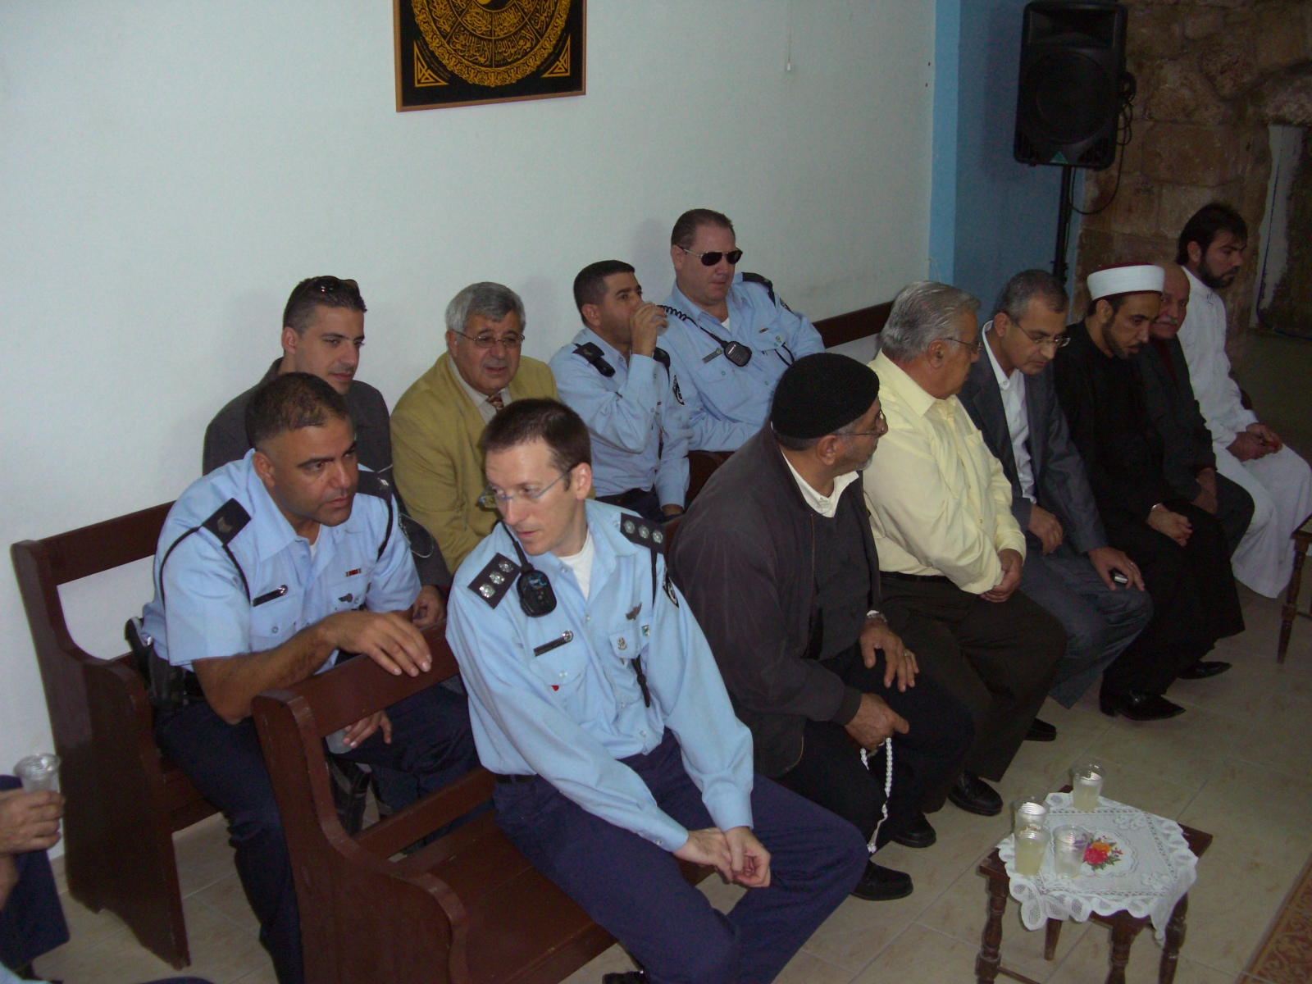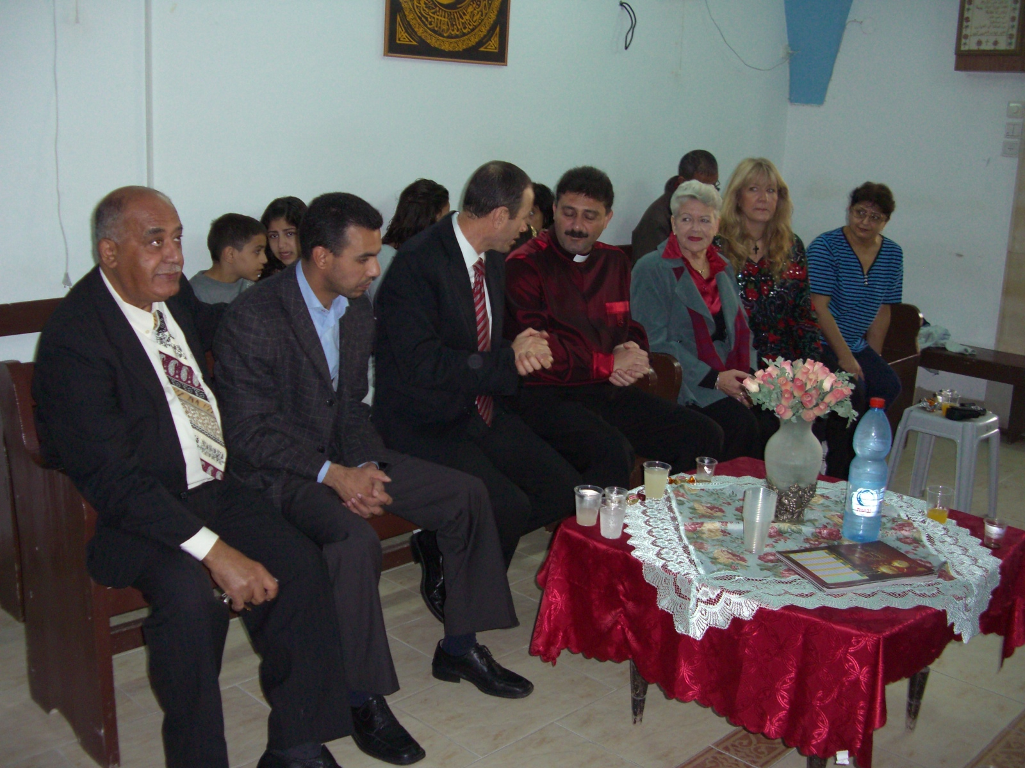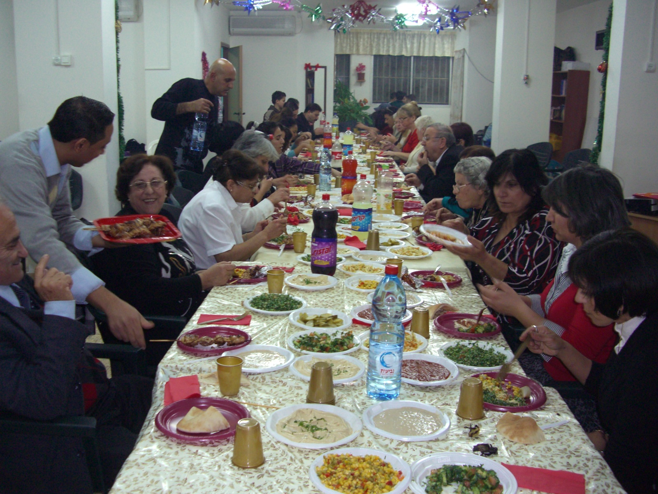

Finally, in January we had a meeting and party with a visiting choir team called “Melody of Peace”, a puppet show, a visiting Pastor Fadi Hana from Nazareth and others.
PRAYER POINTS:
- We hope to see the unbelieving people that were at the party, and also the new and unbelieving people that we visited during Christmas come to church.
- We pray for a blessed and healthy new year for all, especially for “YOU” whom have stood behind us with your prayers and support.

